Data Mining Project
Master in Data Science and Advanced Analytics

NOVA Information Management School
Universidade Nova de Lisboa

Title of Report

Group 99

Muhammad Khuzaima Bashir, 20250441
Student2 Name, 20002222
Student3 Name, 20003333
Student4 Name, 20004444

Fall/Spring Semester 2024-2025

TABLE OF CONTENTS

1. Introduction 1
2. Section Heading Level 1 1
2.1. Level 2 Title 1
2.1.1. Level 3 title 2
2.1.1.1. Level 4 title 2
3. Another Section Heading 2
Bibliographical References (Optional, Not included in page limit) 3
Appendix A (Optional, Not included in page limit) 4
Annexes (Optional, Not included in page limit) 5

Introduction
Phase 1 of this project focused on developing a clear and reliable understanding of AIAI’s customer and flight data, with the aim of identifying meaningful patterns in engagement, travel behaviour, and value contribution. The analysis revealed substantial heterogeneity across the customer base. While some customers demonstrate consistent and sustained engagement over long periods, others show short bursts of activity, and a large proportion remain minimally active. These differences are not superficial and have direct implications for how customers should be analysed, grouped, and managed from a strategic perspective.
A key outcome of Phase 1 was the recognition that customer segmentation could not be approached as a purely modelling exercise applied to an existing dataset. The underlying data structure presented several challenges that needed to be addressed before clustering could be meaningfully performed. Customer attributes and flight activity exist at different levels of granularity, and their relationship is inherently time dependent. Without careful handling, segmentation results would risk reflecting data artefacts rather than genuine behavioural differences.
The first step in preparing the data involved integrating customer level and flight level datasets. Customers may have multiple flight records across different months, while others may have no recorded flight activity at all. To ensure that the analysis did not implicitly exclude low activity or inactive customers, a left join strategy was adopted using the loyalty identifier as the common key. This ensured that all customers remained represented in the dataset, regardless of activity level. Explicit alignment of key data types was also performed to ensure consistency and avoid silent join errors.
Following integration, targeted data consistency checks were applied to identify logically invalid records. Rather than focusing only on missing values, this validation step addressed structural anomalies, such as flight records with zero recorded travel distance. From a domain perspective, such records are not meaningful and are more likely to originate from upstream data issues than actual customer behaviour. These records were removed prior to aggregation to prevent invalid values from propagating into customer level features and influencing segmentation outcomes.
Preserving temporal behaviour was another critical consideration. A direct aggregation of flight data at the customer level would remove important information about when customers travel, including month wise activity patterns and seasonal effects. To address this, flight activity was first structured around an explicit year and month representation, allowing behaviour to be tracked at a monthly resolution before controlled aggregation. This approach ensured that temporal dynamics were retained while still producing a customer level dataset suitable for clustering.
Building on this structure, feature engineering focused on representing both when and how customers travel. Temporal features were designed to capture seasonal preferences and peak period behaviour in a compact and interpretable form. In parallel, behavioural features transformed raw activity totals into normalised measures that account for differences in tenure and activity span. Together, these decisions ensure that the dataset used for segmentation meaningfully represents customer behaviour and value, providing a robust foundation for the analysis presented in the remainder of this report for AIAI

Methodology:
This section describes the analytical approach used to construct and evaluate customer segments for AIAI. The methodology was designed to balance statistical rigor with business interpretability, ensuring that the resulting segments are both analytically defensible and practically actionable.

Data integration
Customer level and flight level datasets were combined using the loyalty identifier as the common key. A left join strategy was applied to ensure that all customers were retained in the analysis, including those with no recorded flight activity. This decision was important to avoid biasing the segmentation toward already active or engaged customers. Prior to merging, key fields were explicitly aligned in terms of data type and format to prevent silent join errors and ensure record level consistency.

Data validation and consistency checks
After integration, targeted validation checks were performed to identify logically invalid records that could distort downstream analysis. The focus was placed on structural inconsistencies rather than missing values alone. In particular, flight records with zero recorded travel distance were identified as invalid, as a completed flight necessarily implies a positive distance. These records were removed prior to aggregation to prevent erroneous values from propagating into customer level summaries and behavioural features. This conservative approach prioritised analytical integrity over maximising dataset size.

Temporal feature engineering
Based on the monthly structure, temporal features were constructed to capture when customers travel rather than relying on raw calendar fields. Monthly flight indicators and counts were aggregated into seasonal flight volumes, allowing broader travel patterns to be identified while reducing dimensionality. A peak season indicator was introduced to capture summer travel behaviour, which serves as a proxy for leisure oriented travel in the absence of explicit trip purpose data. In addition, a dominant travel season was derived for each customer to provide a concise and interpretable summary of their primary temporal travel pattern.

Behavioural feature engineering
Behavioural features were designed to capture how customers travel rather than simply how much they travel. Raw activity totals were normalised into per unit and ratio based measures to account for differences in tenure and activity span. These features include travel frequency per active month, value per flight, loyalty point redemption behaviour, average distance per flight, and the proportion of flights taken with companions. Normalisation allows customers with different engagement histories to be compared on a like for like basis and improves the stability and interpretability of clustering results.

Data transformation and representation
Several transformation steps were applied to ensure that features were suitable for clustering and comparable across customers.
Continuous features with heavy right skew, particularly those related to value accumulation and distance travelled, were log transformed to reduce the influence of extreme values and improve cluster stability. This step prevents a small number of high value customers from disproportionately shaping distance based similarity measures.
Binning was applied to selected continuous variables to create categorical representations where relative position was more meaningful than precise numeric differences. This was particularly useful for tenure and value related attributes, allowing customers to be grouped into interpretable bands rather than compared on raw scales that may not reflect meaningful behavioural differences.
Feature encoding was applied using a feature aware strategy to ensure numerical compatibility with clustering algorithms while preserving behavioural meaning. Low cardinality nominal features were one hot encoded to avoid imposing artificial order and to allow categories to contribute independently to similarity calculations. In contrast, discretized features with a clear behavioural or value based progression were ordinally encoded to preserve relative intensity and ordering. This hybrid approach ensures stable distance based clustering while maintaining interpretability of customer segments
Feature scaling was applied for distance based clustering methods to ensure that all numerical features contribute proportionately to similarity calculations. Without scaling, features with larger numeric ranges would dominate clustering outcomes regardless of their behavioural relevance. Scaling was applied selectively and consistently across KMeans and hierarchical clustering, while RFM segmentation retained its original scale due to its rule-based nature.

Segmentation approach
To ensure robustness and avoid reliance on a single analytical perspective, multiple segmentation approaches were evaluated. Classical unsupervised clustering techniques were applied alongside a value driven segmentation framework. This allowed comparison between statistically derived clusters and segments that are more directly aligned with business concepts of customer value and engagement. Model selection and evaluation focused not only on separation metrics, but also on interpretability and practical relevance of the resulting customer groups.

Results And Validation:

Value Based Segmentation:

K-Means clustering results and validation
K Means clustering was evaluated across multiple configurations to identify a solution that balances statistical quality with business interpretability. The inertia pattern shown in the Appendix indicates a clear change in slope between three and four clusters, after which improvements in within cluster compactness become marginal (Fig 1, Appendix). This suggests that solutions beyond four clusters add complexity without meaningful structural benefit.
Silhouette analysis further supports this choice. Although smaller cluster counts achieve higher silhouette values, these solutions are overly coarse and group customers into broad categories that obscure important differences in value and engagement (Fig 2, Appendix). At four clusters, the silhouette score remains positive and stable, and the silhouette distribution shows that most customers are assigned with reasonable confidence, indicating a stable partition (Fig 3, Appendix).
Cluster profiling reveals clear differentiation across customer lifetime value, travel frequency, loyalty point behaviour, and tenure, forming intuitive value tiers (Fig 4, Appendix). Visualisation in reduced feature space confirms coherent cluster separation (Fig 5, Appendix). The cluster size distribution reflects a long tail value structure, with a dominant low value group and smaller high value segments (Fig 6, Appendix), supporting the selection of a four cluster K Means solution.

Hierarchical clustering results and validation
Hierarchical clustering was evaluated to assess whether value based customer structure emerges naturally without imposing a predefined number of clusters. Different linkage methods were compared using an explained variance style metric, with Ward linkage consistently outperforming complete, average, and single linkage approaches across cluster counts (Fig 7, Appendix). This indicates stronger internal cohesion and more meaningful separation when variance minimisation is prioritised.
Based on this comparison, Ward linkage was selected and a four cluster solution was examined in detail. The dendrogram in the Appendix shows a clear separation point at the chosen cut level, supporting the stability of a four cluster structure without excessive fragmentation (Fig 8, Appendix). Cluster profiling reveals distinct differences across travel frequency, value accumulation, redemption behaviour, and tenure, although separation along pure value dimensions is less pronounced than in the K Means solution (Fig 9, Appendix).
Visualisation in reduced feature space confirms that clusters are coherent and reasonably well separated, though with more overlap than observed in centroid based clustering (Fig 10, Appendix). The cluster size distribution again reflects a long tail value structure, with one dominant low engagement group and smaller differentiated segments (Fig 11, Appendix). Overall, hierarchical clustering provides useful structural insight, but offers lower interpretability and operational clarity compared to the K Means value based solution.

RFM segmentation results and validation:
RFM segmentation shows a distinct distribution of customers across value based segments. Most customers fall into the Loyal and Potential Loyalists categories, while the Champions segment represents a smaller group with higher engagement. The At Risk and Lost segments capture customers with reduced or minimal activity levels (Fig 12, Appendix).
Points accumulation differs clearly across segments. Champions and Loyal customers exhibit higher points accumulation, whereas Potential Loyalists show moderate levels. In contrast, At Risk and Lost customers demonstrate substantially lower accumulation, reflecting reduced engagement with the loyalty program (Fig 13, Appendix).
Average RFM scores follow the same structure. Champions score highest across recency, frequency, and monetary dimensions, followed by Loyal customers. Potential Loyalists occupy an intermediate position, while At Risk and Lost segments display consistently lower scores across all three dimensions (Fig 14, Appendix).

Conclusion: Value-Based Segmentation
Value-based segmentation was explored using three complementary approaches: K Means clustering, hierarchical clustering, and RFM segmentation. Each method revealed different aspects of customer value, but their effectiveness varied in terms of clarity, stability, and alignment with business interpretation.
K Means clustering produced a stable four-cluster solution that captured broad differences in customer value and engagement. The clusters were statistically sound and showed meaningful variation across lifetime value, travel activity, and loyalty behaviour. However, the resulting segments required additional interpretation to translate distance-based groupings into clear value tiers.
Hierarchical clustering provided insight into the underlying similarity structure of customers and confirmed the presence of natural groupings in the data. While useful for validation, hierarchical clusters exhibited greater overlap and lower interpretability, making them less practical for direct value-based categorisation at scale.
RFM segmentation delivered the clearest and most interpretable representation of customer value. By directly modelling recency, frequency, and monetary contribution, it produced segments that align naturally with customer lifecycle stages and economic impact. Compared to algorithmic clustering methods, RFM offers the most transparent and actionable value-based segmentation and therefore represents the strongest approach for identifying and prioritising customer value in this analysis for AIAI.

Temporal Clustering - Seasonal Distribution Segmentation
While value based segmentation focuses on how much customers contribute, temporal clustering is designed to understand when customers travel. The objective of this analysis is to identify distinct seasonal travel patterns by segmenting customers according to the distribution of their travel activity across the year, independent of overall travel volume or economic value.
This perspective captures a different dimension of customer behaviour. Customers with similar activity levels may exhibit very different temporal preferences, such as concentrating travel in peak summer months, travelling evenly throughout the year, or primarily flying during off peak periods. These patterns are not captured by value based clustering but are important for understanding travel intent and demand seasonality.
To isolate temporal behaviour, clustering was performed using features that represent seasonal distribution rather than raw flight counts. This ensures customers are grouped by timing patterns rather than usage intensity. Both K Means and hierarchical clustering were applied within this framework to assess the stability and interpretability of seasonal segments.

K Means results and validation:
K Means clustering was applied to seasonal distribution features to identify groups of customers with similar travel timing patterns. The inertia pattern shown in the Appendix indicates a sharp reduction within cluster variance up to four clusters, after which further improvements become marginal, suggesting limited benefit from additional segmentation (Fig 15, Appendix).
Silhouette analysis supports this configuration, with average silhouette scores remaining positive and stable at four clusters. The silhouette distributions show that most customers are assigned with positive confidence, indicating coherent seasonal groupings rather than forced separation (Fig 16, Appendix).
Cluster sizes are relatively balanced compared to value based clustering, reflecting the more even distribution of seasonal preferences across the customer base (Fig 17, Appendix). Visualisation in reduced feature space confirms meaningful separation between clusters, with centroids aligned along the dominant seasonal travel dimension, capturing distinct temporal patterns such as peak season concentration and evenly distributed travel behaviour (Fig 18, Appendix).

Hierarchical clustering results and validation:
Hierarchical clustering was applied to the seasonal distribution features to examine whether temporal travel patterns emerge naturally without enforcing predefined cluster boundaries. Comparison of linkage methods shows that Ward linkage consistently explains a higher proportion of variance than complete, average, and single linkage approaches, indicating stronger cohesion when variance minimisation is prioritised (Fig 19, Appendix).
Based on this result, Ward linkage was selected and a three cluster solution was examined. The dendrogram illustrates a clear separation at the chosen cut level, suggesting a stable hierarchical structure for seasonal segmentation (Fig 20, Appendix). Cluster profiling shows broadly similar seasonal distributions across clusters, with differences driven more by relative seasonal emphasis than by extreme contrasts in travel timing (Fig 21, Appendix).
The resulting cluster size distribution is moderately imbalanced but less skewed than value based clustering, reflecting variation in seasonal preferences across the customer base (Fig 22, Appendix). Visualisation in reduced feature space confirms coherent but overlapping cluster regions, indicating that temporal patterns are present but less sharply separated than in centroid based clustering (Fig 23, Appendix).

Conclusion - Temporal Clustering:
Temporal clustering was conducted to segment customers based on seasonal travel patterns, independent of travel volume or economic value. Both K Means and hierarchical clustering were applied to assess the stability and interpretability of seasonal segments under different algorithmic assumptions.
K Means clustering produced clearer and more distinct seasonal groupings, with stable separation and relatively balanced cluster sizes. The resulting clusters aligned well with intuitive temporal profiles, such as customers concentrated in peak seasons, off-peak travellers, and those with evenly distributed travel throughout the year. Visualisation in reduced feature space further supported the presence of coherent seasonal patterns captured by the K Means solution.
Hierarchical clustering provided useful structural insight into how seasonal patterns merge at different similarity levels, but the resulting clusters showed greater overlap and weaker differentiation. While Ward linkage performed best among hierarchical methods, the final clusters were less sharply separated and offered lower interpretability compared to K Means.
Overall, K Means emerged as the more effective approach for temporal segmentation in this analysis. It captures seasonal travel behaviour in a clearer and more operationally interpretable manner, making it the preferred method for identifying distinct temporal travel patterns within the customer base.

conclusion:
This analysis establishes the analytical foundation for Data Preparation and Clustering. The findings show that redundancy among distance, points, and redemption metrics should be addressed through feature selection. High zero inflation and skewed distributions will require transformations (e.g., log-scaling or normalization). Segmentation hypotheses include clusters based on travel frequency (occasional vs frequent), companionship behavior (solo vs group), and value generation (high vs low CLV relative to income). The proposed clustering approach will employ standardized and scaled numerical features, removing redundant and low-variance attributes. Categorical attributes such as LoyaltyStatus and EnrollmentType may serve as post-cluster descriptors rather than direct inputs. The expected outcome is a set of distinct, interpretable customer segments that inform personalized engagement strategies, optimized loyalty design, and targeted marketing initiatives.

Bibliographical References (Optional, Not included in page limit)
Use APA Style for the entire document
We suggest that students use a reference manager system (Zotero, Mendeley, EndNote),
Please review the style guide at: https://apastyle.apa.org/style-grammar-guidelines/references/examples:
Author, A. A., Author, B. B., & Author, C. C. (Year). Title of article. Title of Periodical, volume number (issue number), pages.

Appendix A:
Figure 1.
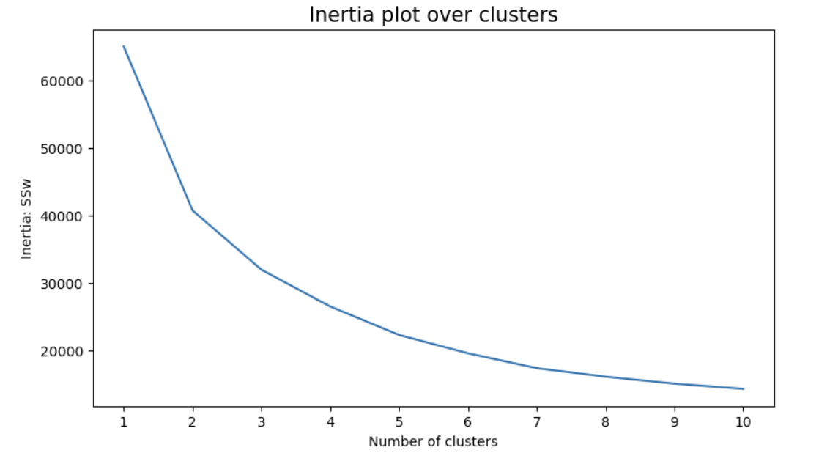
Figure 2.
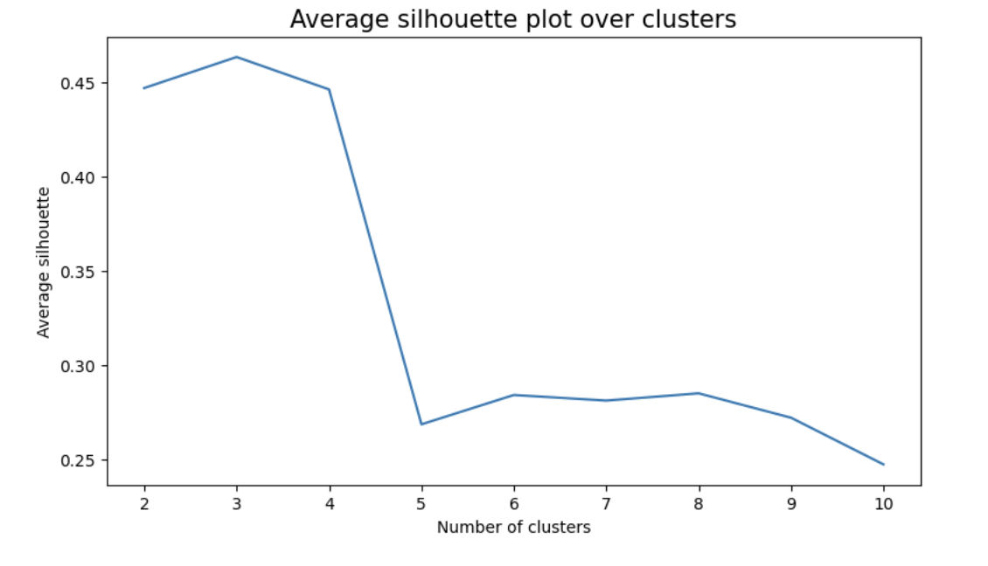
Figure 3.
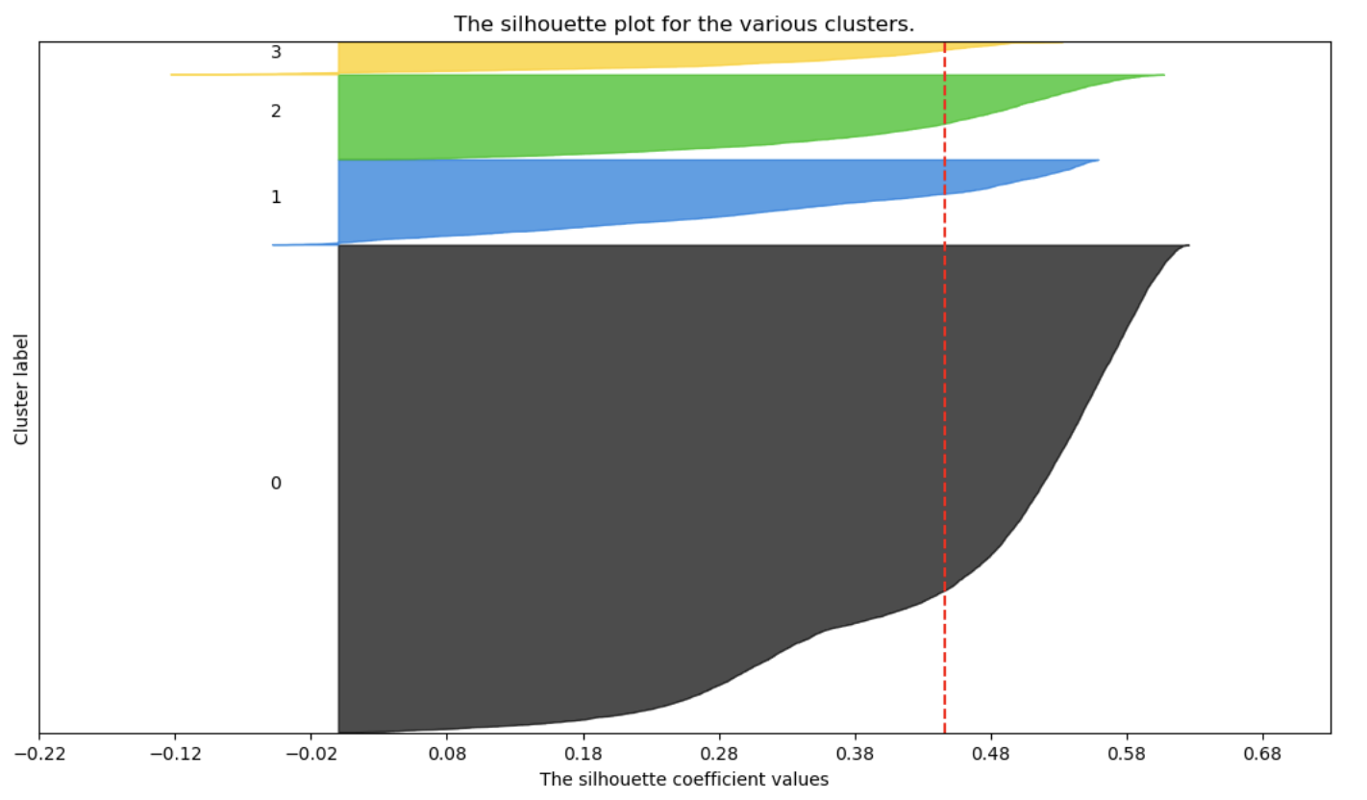
Figure 4.
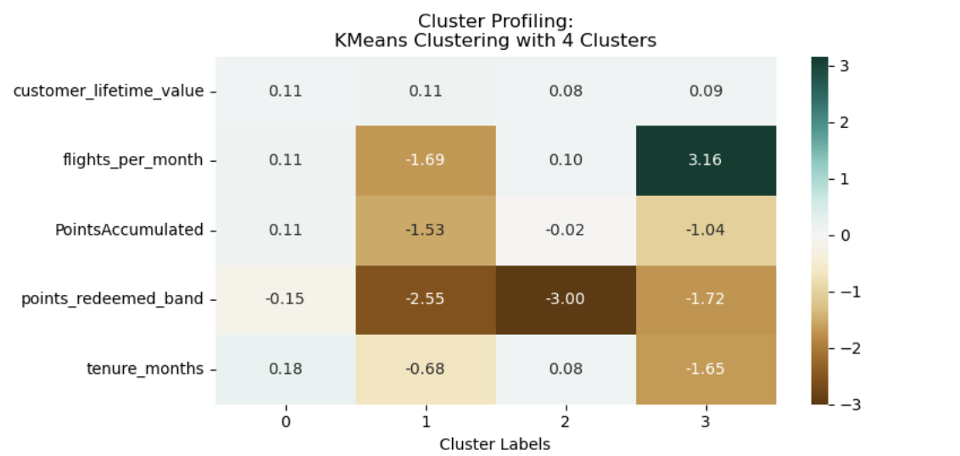

Figure 5.
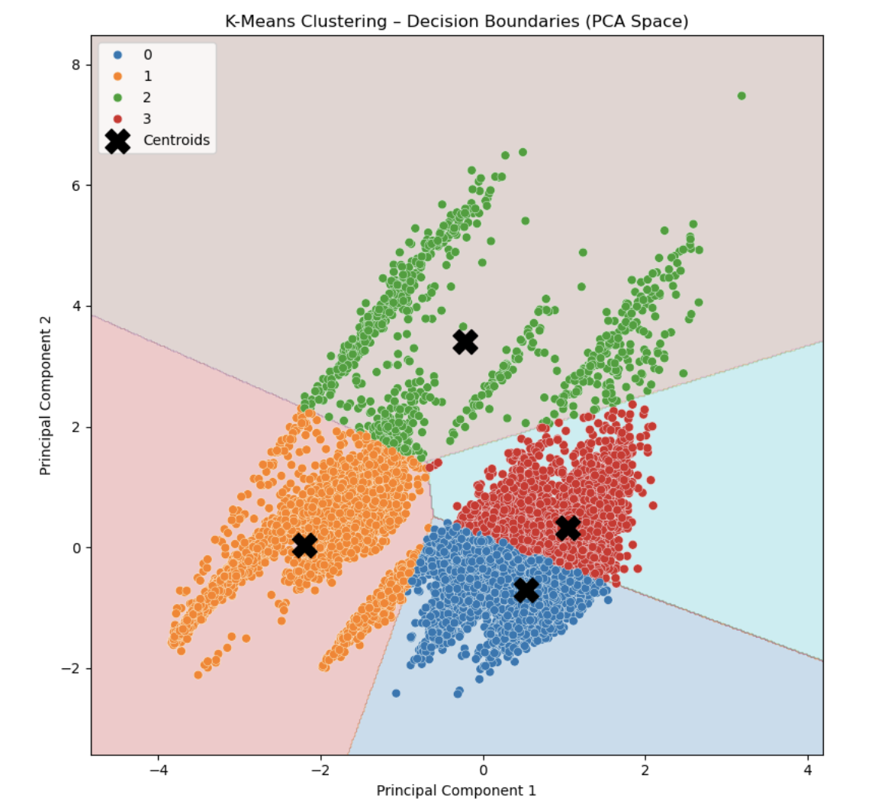

Figure 6.
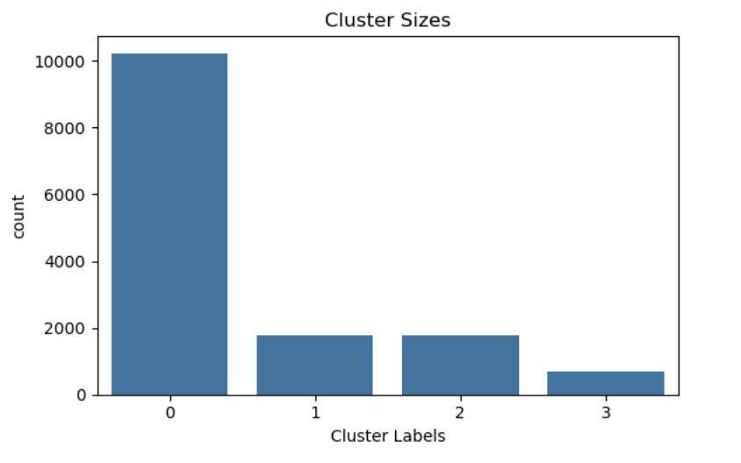
Figure 7.
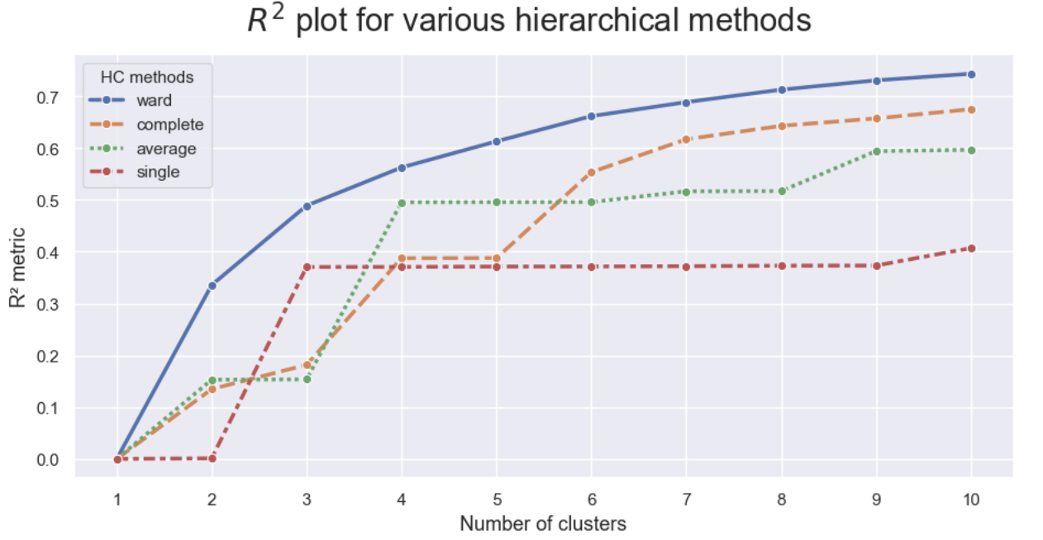

Figure 8.
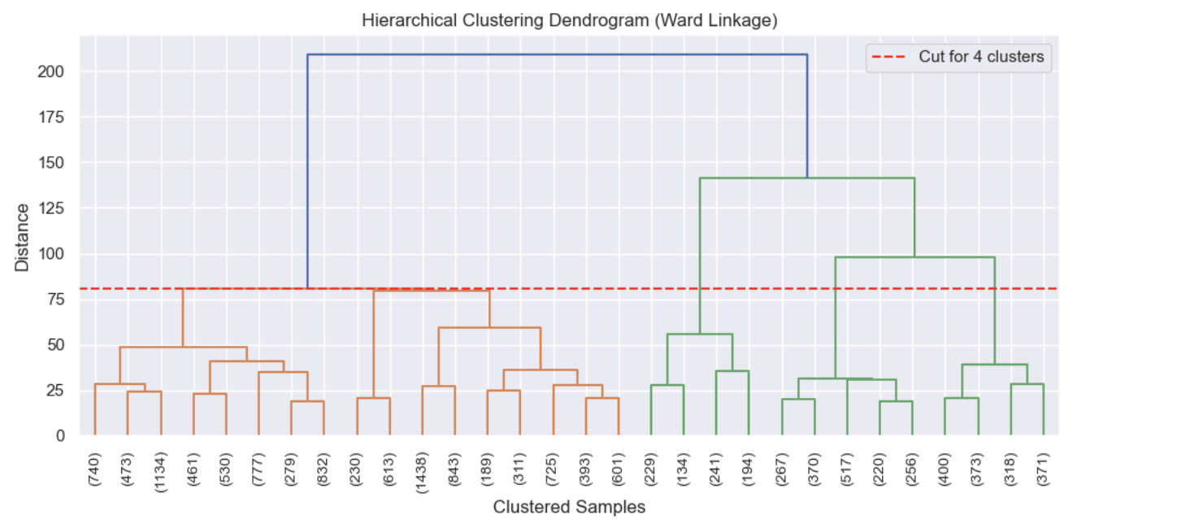
Figure 9.
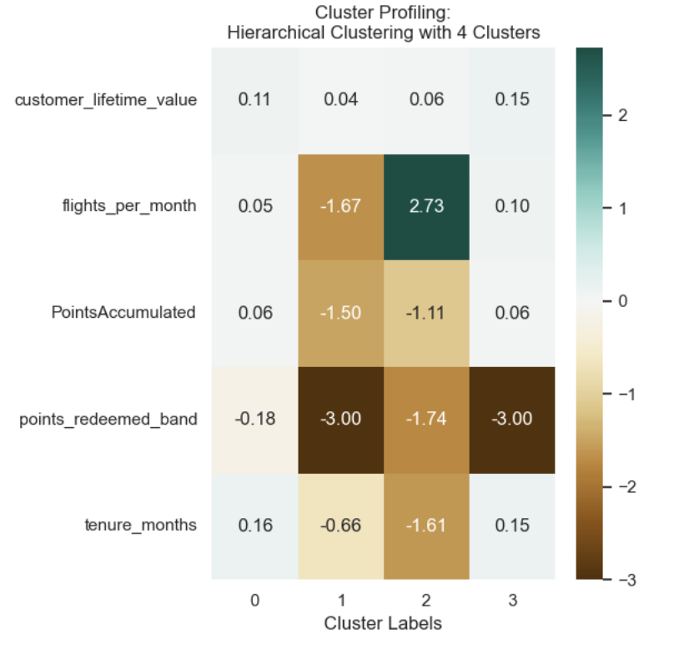
Figure 10.
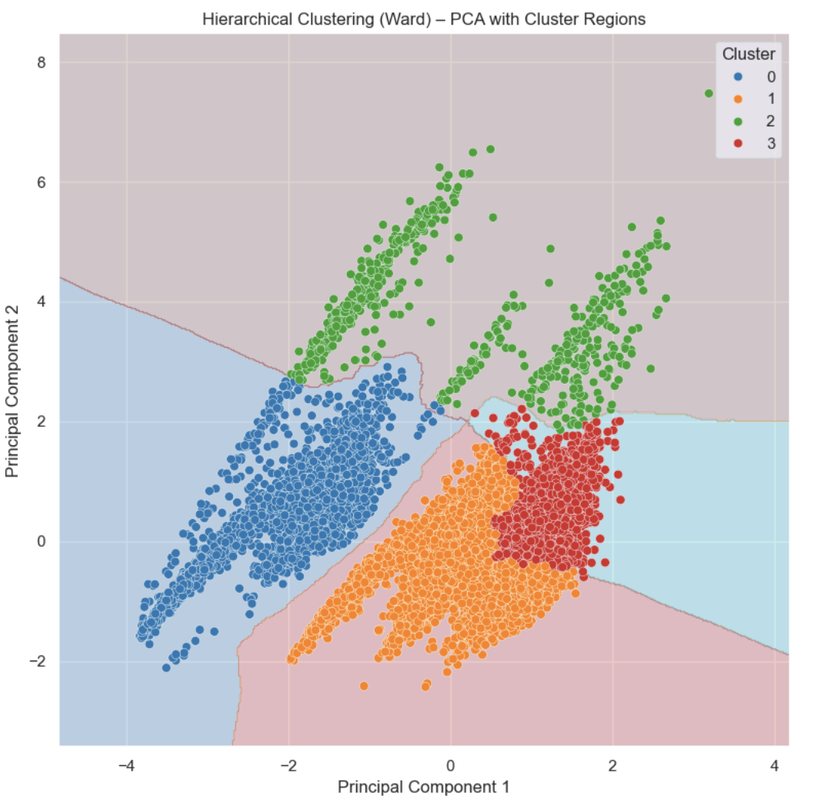

Figure 11.
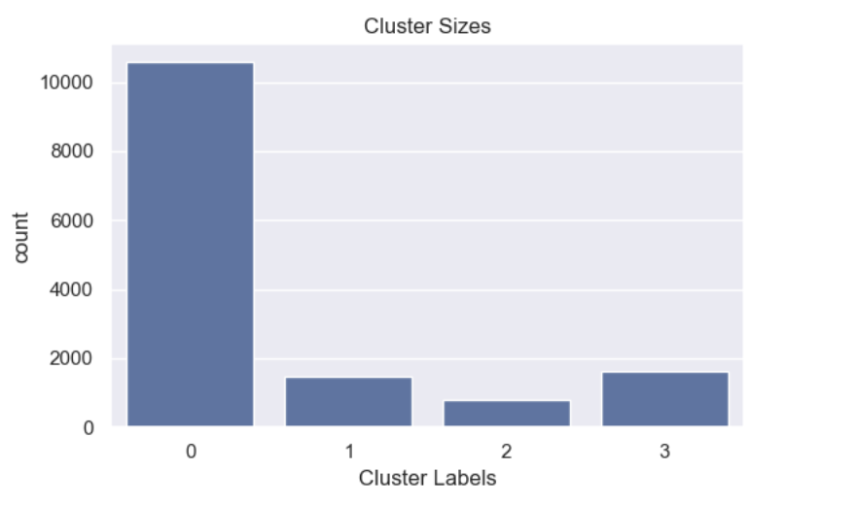

Figure 12.
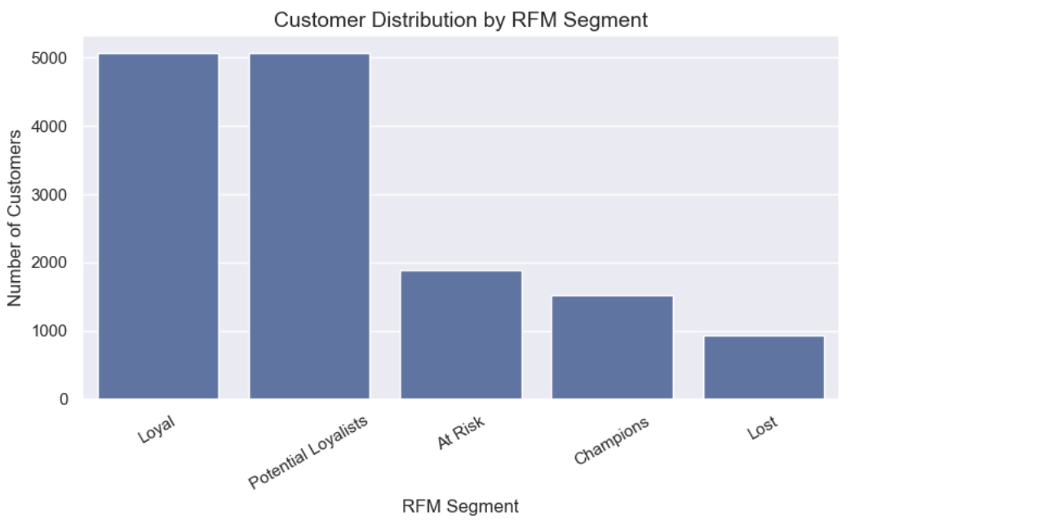
Figure 13.
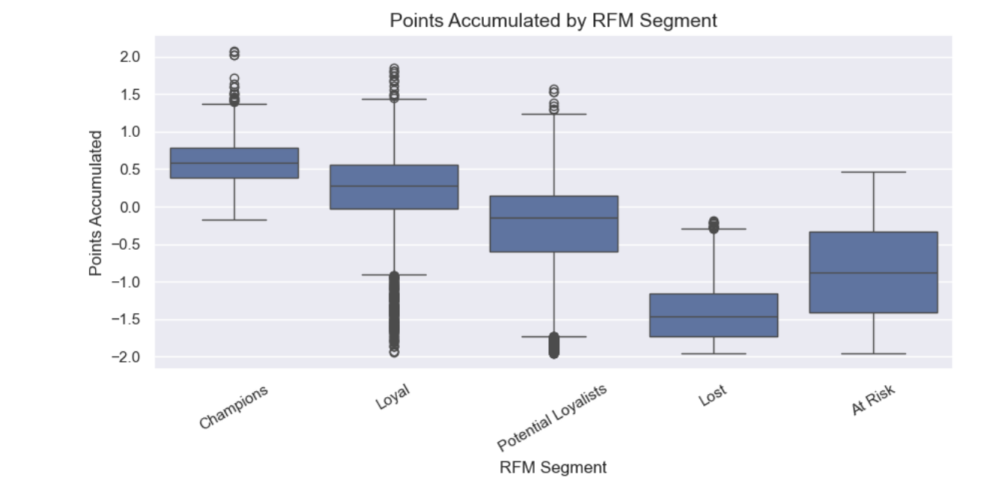
Figure 14.
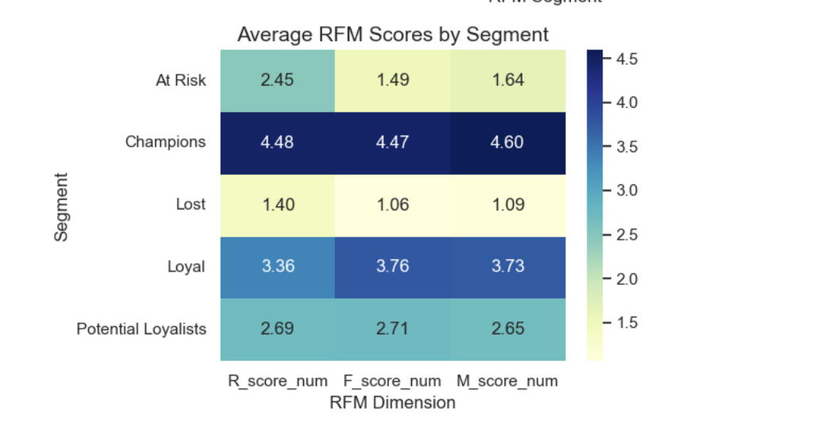
Figure 15.

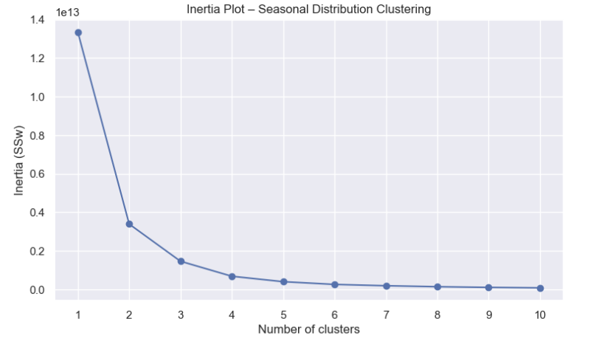

Figure 16.
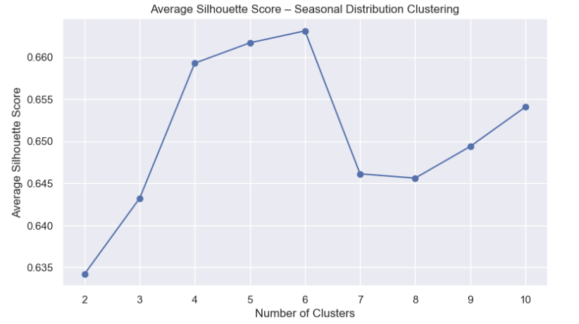
Figure 17.
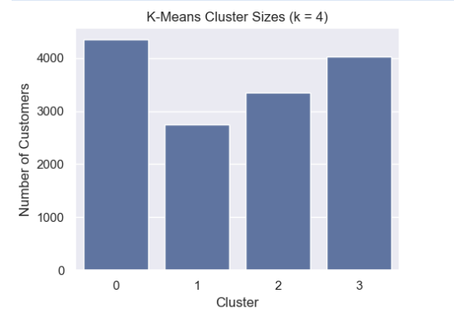

Figure 18.
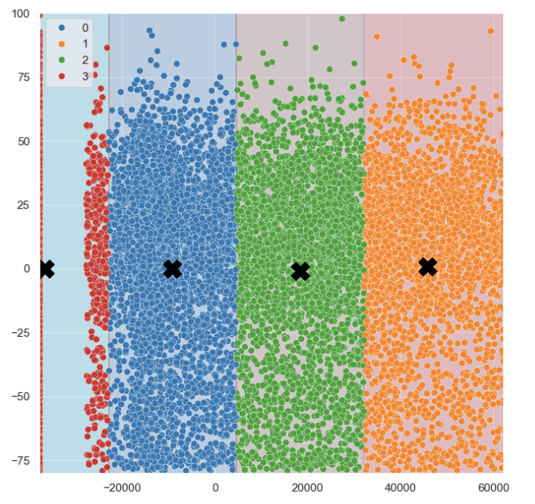

Figure 19.
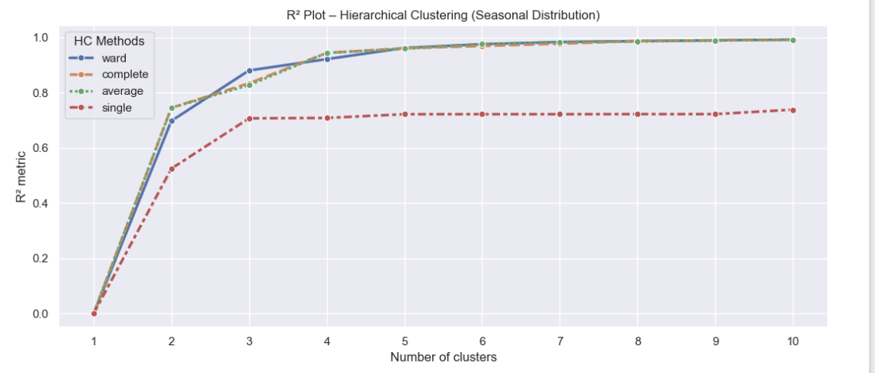

Figure 20.
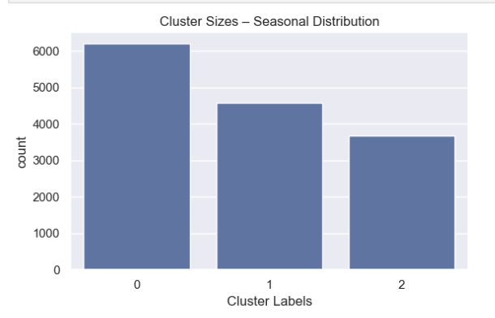

Figure 21.
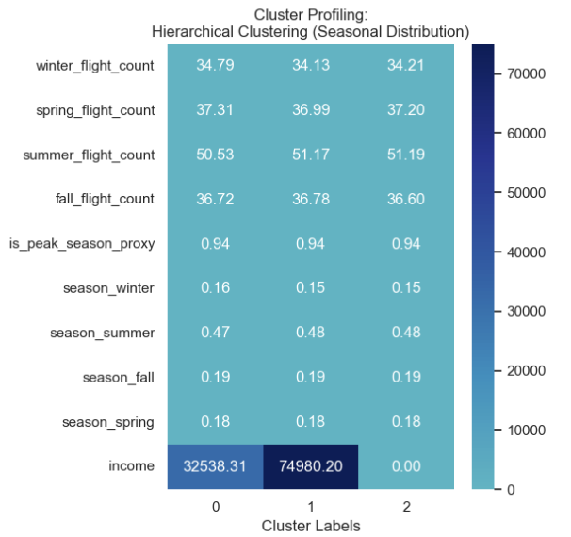

Figure 22.
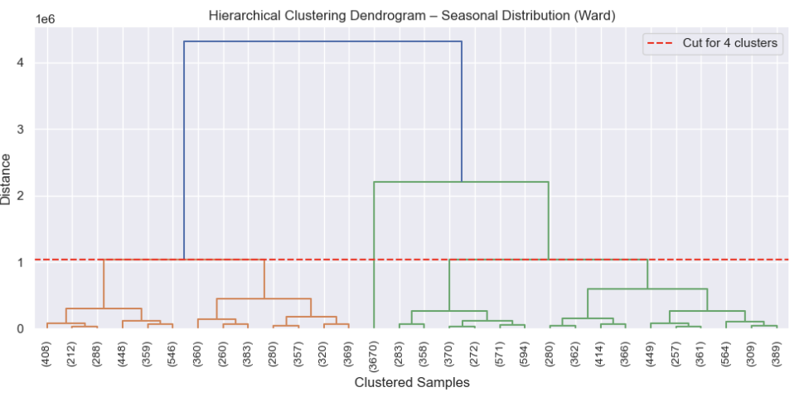

Figure 23.
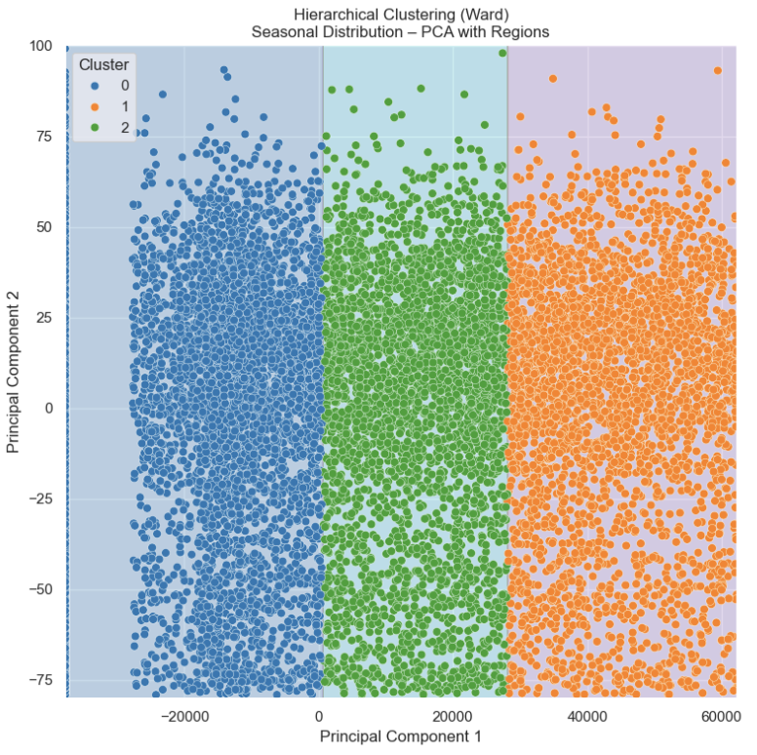

Figure 24.

ANNEX:
AIUsageStatement:
AI tools were used for coding syntax assistance and report proofreading (ChatGPT).

Contribution Statement:
Muhammad Khuzaima Bashir (StudentID:20250441) - Customer and Flights initial separate & combined analysis, Poster

Marta Boavida (StudentID:20240519) – Customer and Flights separate dataset analysis, Report writing

SampleStudent (StudentID:xxxxxxxx) -

SampleStudent (StudentID:xxxxxxxxxx) -

All members contributed to collaborative discussions and ideation.

